NED UNIVERSITY
EF-101 · SYSTEM UNDERSTANDING PROJECTS · FALL 2026
PROJECT REPORT
EF101-P09
Local Network Design and
Performance Investigation
cccccccccccccc
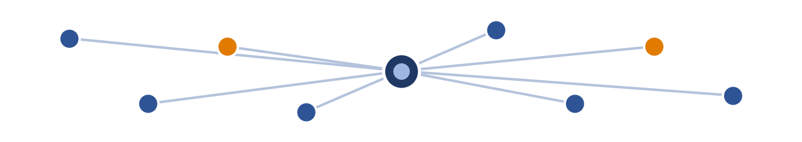
PROJECT ID  EF101-P09 | GROUP SIZE  3 students | SUBMISSION  Week 13, Mon, 9 November 2026
GROUP MEMBERS
# | Name | Student ID
1 | MUHAMMAD YOUSUF KHAN | EE-26238
2 | MUHAMMAD ANAS SIDDIQUI | EE-26228
3 | MUHAMMAD FARAZ ALI | EE-26230
Section: E

2. Problem statement
Every day we use laptops, phones and printers that exchange data without us noticing how. Many users cannot say why a device has a particular IP address, why a file copies quickly to a neighbouring laptop but a web page loads slowly, or why Wi-Fi becomes slower in another room. This project addresses the lack of understanding of the physical and logical components that allow devices to communicate in a small local-area network (LAN).
We therefore designed, configured and investigated a small LAN of 6 end devices, documented its addressing, and measured its behaviour (latency, throughput, wired versus wireless performance and Internet speed) so that the theory of networking can be checked against real measurements.

3. Objectives
- Design and draw a LAN topology showing the router, switch/access point and end devices, and identify wired and wireless links.
- Record and explain the addressing of at least three devices (IP address, subnet mask, default gateway, MAC address) and determine whether it is static or assigned by DHCP.
- Measure local connectivity and round-trip latency with ping, and explain the role of DNS by resolving a domain name.
- Measure local file-transfer throughput and Internet speed, and compare wired with wireless (or near with far wireless) conditions.
- Explain the difference between a switch, router, access point and network interface card, and what happens when the default gateway is unavailable.
- Analyse latency versus bandwidth, Wi-Fi behaviour, DHCP versus static addressing, local versus Internet traffic and packet movement.

4. System architecture
The demonstrated network is a single-subnet star topology. All devices connect to one central device (switch / access point), which is connected to the router that provides the default gateway and the link to the Internet. Wired devices use Ethernet cables; wireless devices use Wi-Fi.
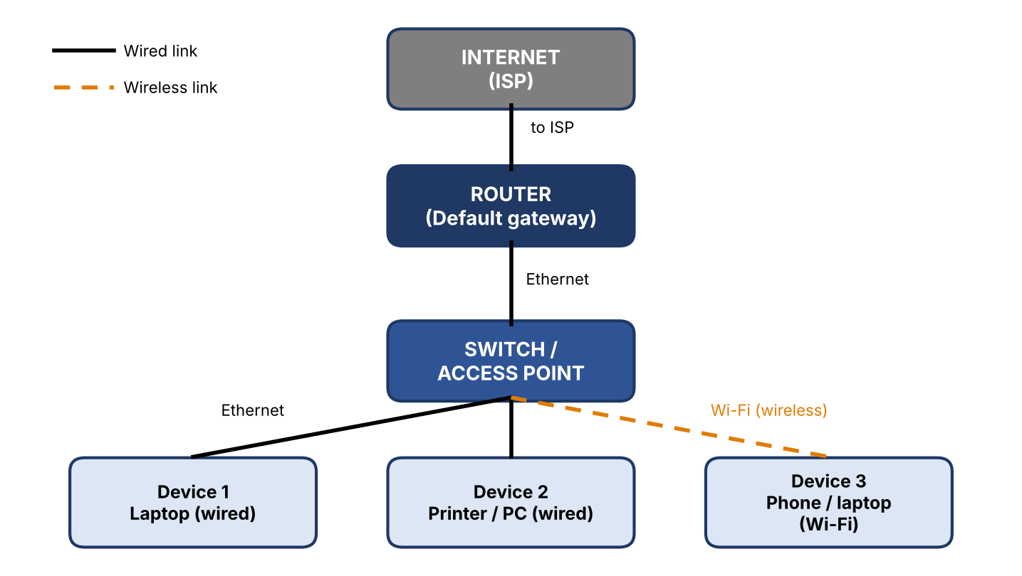
Figure 1: Network topology of the demonstrated LAN

4.1 Components
Device | Role | Link type | Explanation
Router 3 | Default gateway, DHCP/DNS forwarder, NAT | Wired to switch / ISP | Connects the LAN to other networks (the Internet) and forwards packets between networks.
Switch / access point | Connects local devices | Wired | Forwards frames inside the LAN using MAC addresses; an access point does the same for Wi-Fi clients.
End device 1 PC0 | desktop | Wired | Source and destination of data.
End device 2 Laptop0 | Laptop | Wired | Source and destination of data.
End device 3 Printer0 | Printer | Wired | Source and destination of data.

4.2 Switch, router, access point and network interface card
Component | What it does
Network interface card (NIC) | The hardware inside every device (Ethernet or Wi-Fi adapter) that has the MAC address and sends and receives signals on the medium.
Switch | Layer-2 device that learns which MAC address is on which port and forwards frames only to the correct port. It connects devices within one network and does not route between networks.
Router | Layer-3 device that forwards packets between different networks using IP addresses and a routing table. In a home network it also provides DHCP, NAT and the default gateway.
Access point (AP) | Connects wireless clients to the wired LAN. It works like a switch for Wi-Fi; many home routers contain a router, a switch and an access point in one box.

5. Technology selection
Tool / hardware | Purpose | Reason for choice
Laptops / phone / printer | Real end devices and real measurements | Required: at least one measurement on actual hardware.
Router / access point | Provides LAN, DHCP and Internet | Isolated personal network – no university infrastructure is touched.
ipconfig /all (or ip addr, ifconfig) | Read IP, mask, gateway, MAC, DHCP status | Built into the operating system.
Ping | Test connectivity and round-trip time | Standard ICMP tool, no installation.
Nslookup | Resolve a domain name and show the DNS server | Shows DNS in action.
File copy | Measure local throughput | Large file of known size and a stopwatch (size ÷ time).
Speed-test service | Measure Internet download/upload and latency | Free and widely used.
Cisco Packet Tracer | Simulated topology / configuration experiments | Safe for configuration without affecting real networks.

6. Data design
This project has no database; the data are the addressing information and the experiment variables.

6.1 IP-addressing table
Device | IP address | Subnet mask | Default gateway | MAC address | Assignment (DHCP/static)
Router | 192.168.1.1 | 255.255.255.0 | - | 00E0.F963.A301 | Static
PC 0 | 192.168.1.6 | 255.255.255.0 | 192.168.1.1 | 0007.ECD3.EB66 | DHCP
LAPTOP 0 | 192.168.1.3 | 255.255.255.0 | 192.168.1.1 | 0001.97E0.C98E | DHCP
PC 1 | 10.0.0.5 | 255.255.255.0 | 10.0.0.1 | 0001.976C.73BA | DHCP
Table 1: IP-addressing table of the demonstrated network.

6.2 Experiment variables
Experiment | Independent variable (what we changed) | Measured variable
Local ping | Source/destination pair, wired vs wireless | Round-trip time (ms), packet loss (%)
Local file transfer | Wired vs wireless; near vs far | Transfer time (s), throughput (MB/s or Mbps)
Internet speed test | Wired vs wireless | Download/upload (Mbps), latency (ms)
Wi-Fi distance | Distance / walls between device and access point | Signal strength, throughput, ping
Controlled conditions: same file, same devices, same time of day, no other heavy downloads running. File size = 42 B.

7. Implementation / method
The tasks were carried out in the following order:
- Connected the devices as in Figure 1 and drew the topology, marking wired and wireless links.
- On each device ran ipconfig /all (or the equivalent) and recorded IP address, subnet mask, default gateway, MAC address and the "DHCP enabled" field to decide whether the address was manual or from DHCP.
- Used ping between devices (and to the gateway) to test connectivity and recorded round-trip latency (minimum/average/maximum) for each pair.
- Used nslookup http://network-project to resolve a domain name.
- Copied a file of known size between two devices and calculated throughput = file size ÷ time.
- Ran an Internet speed test on wired and on wireless connections.
- Repeated the file transfer and ping near and far from the access point (or wired vs wireless).
- Disconnected/disabled the gateway (router uplink) in a controlled way on our own network and observed which communication still worked.

7.1 Role of DNS
Humans use names such as example.com, but devices communicate with IP addresses. The Domain Name System (DNS) is a distributed directory that translates a name into an IP address. The device asks its configured DNS server (often the router, which forwards to the ISP's resolver); the answer is cached for some time. Result in our network: http://network-project resolved to 172.168.2.1 using DNS server 192.168.1.4.

7.2 DHCP versus static addressing
With DHCP a server (usually the router) automatically leases an IP address, mask, gateway and DNS server to each device; this is simple and avoids duplicate addresses. With static addressing an administrator enters the values manually; the address never changes, which suits servers and printers, but mistakes can cause conflicts. In our DNS Server, PC , Laptop , Printer , Ip-Phone use DHCP and DHCP server and HTTP-server use static IP.

7.3 How packets move through the network
Inside the LAN: the sender sees that the destination IP is in the same subnet (by comparing with its subnet mask), uses ARP to find the destination MAC address, and sends the frame to the switch, which forwards it to the correct port. To the Internet: the destination IP is in another network, so the device sends the packet to its default gateway (router). The router forwards it (with NAT) towards the ISP, and routers along the path forward it hop by hop until it reaches the destination; the reply returns the same way.

7.4 When the default gateway is unavailable
Devices in the same subnet remain connected to each other, because local traffic is delivered by the switch using MAC addresses and does not need the router. Communication with other networks fails: no Internet access, web pages do not load, and a DNS server outside the LAN cannot be reached, so domain names stop resolving even though pinging local IP addresses still works. Observed result in our test: DEFault Gateway was not assign to the devices connected to LAN which restricted them to connect from one network to another.

8. Testing

8.1 Test cases
# | Test | Expected
1 | Ping device 1 → device 2 | Replies, low latency
2 | Ping device → default gateway | Replies
3 | Ping Internet host (IP address) | Replies
4 | nslookup domain | IP address returned
5 | Local file transfer | Completes; throughput recorded
6 | Internet speed test | Download/upload recorded
7 | Gateway unavailable | Local ping works, Internet fails

8.2 Ping results
Source → destination | Link type | Min (ms) | Avg (ms) | Max (ms) | Packet loss
Device 1 → Device 2 | wired | 0 | 0 | 0 | 0
Device 2 → Gateway | wired | - | - | - | 0
Device 1 → Internet host | wired | 0.8 | 1 | 1.2 | 0

8.3 File transfer and speed tests
Condition | File size | Time (s) | Throughput
Wired | 4B | 0.08sec | 525bytes/sec

Internet test | Download (Mbps) | Upload (Mbps) | Latency (ms)
Wired | 8.7Mbps | 9.18Mbps | 19
Wireless | 9.8Mbps | 10.1Mbps | 15
Note: throughput in MB/s × 8 = Mbps. At least one of these measurements was taken on real hardware laptop.

9. Results and analysis

9.1 Screenshots
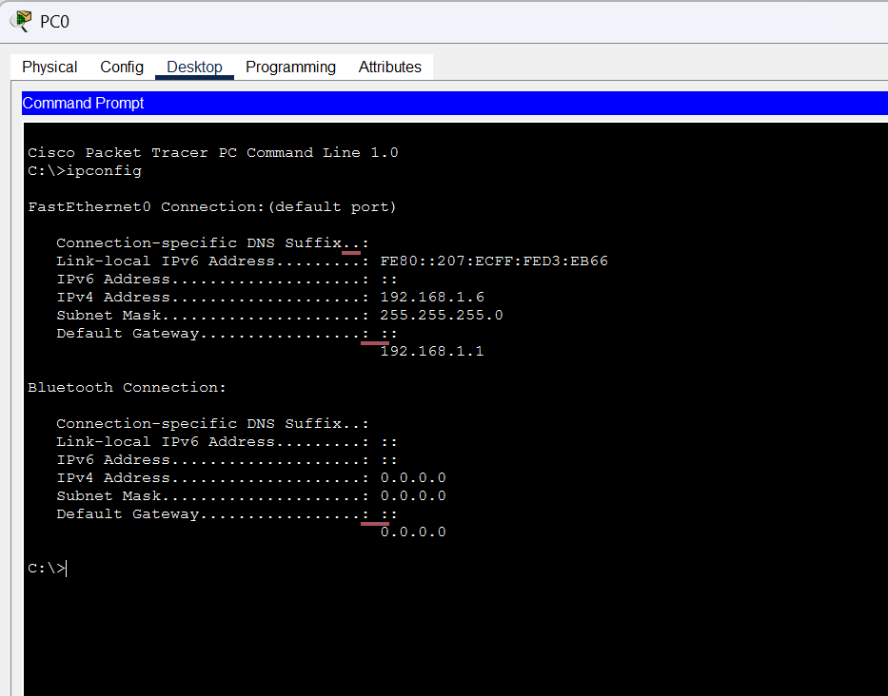
Figure 2 – ipconfig of a device

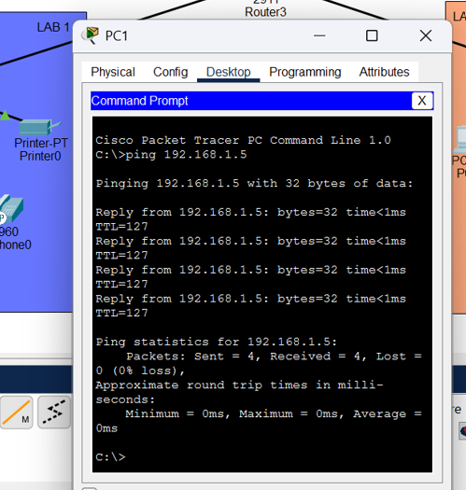
Figure 3 – ping results

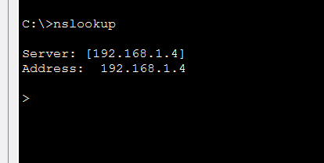
Figure 4 – nslookup output

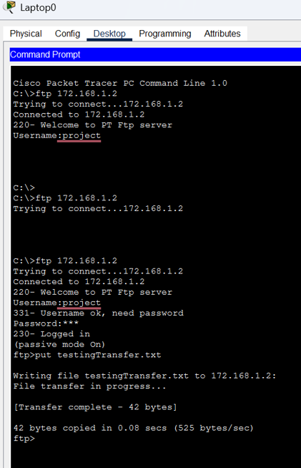
Figure 5 – file-transfer time

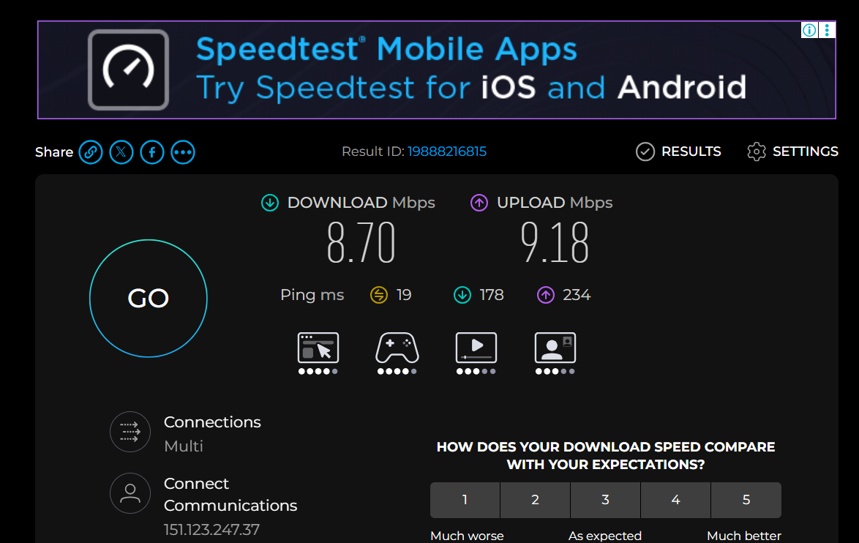
Figure 6 – speed-test result

9.2 Latency versus bandwidth
Latency is the time one packet needs to travel to the destination and back (ms); bandwidth/throughput is how much data can be transferred per second (Mbps). They are independent: a satellite link can have high bandwidth but high latency, while a slow link can have low latency. Large file transfers depend mainly on bandwidth; games, video calls and small web requests are sensitive to latency.

9.3 Why Wi-Fi performance changes
Wi-Fi signal weakens with distance and when passing through walls, furniture and people. Interference from other access points, Bluetooth devices and microwave ovens on the same channel, and sharing the air with other devices (only one transmits at a time), reduce throughput and increase latency and packet loss. The 5 GHz band is usually faster but has shorter range than 2.4 GHz.

9.4 Wired versus wireless
Typically wired has lower and more stable latency and higher throughput

9.5 Local versus Internet traffic
Local traffic stays inside the LAN, crosses only the switch/access point, and is usually fast with low latency. Internet traffic passes through the router and the ISP and many other routers, is limited by the ISP's bandwidth, and has higher latency

10. Limitations
- The network is small and isolated; results do not represent a university or busy network.
- Wi-Fi measurements depend on time of day, nearby networks and device position, so each was repeated only 1 times.
- The Internet speed test depends on the ISP and the test server at that moment.
- The file-transfer time was measured manually and includes disk speed of the devices, not only the network.
- In a real product we would add monitoring, security (WPA3, firewall), VLANs and redundancy.

11. AI, libraries and external resources
Tool / source | Use
Cisco Packet Tracer | Topology drawing / simulation.
Speed-test service | Internet speed measurement. OKLA
Safety / Ethics: all experiments were done only on devices and networks owned by the group or with permission. No university infrastructure was disrupted.

12. Individual contributions
Member | Student ID | Contribution
MUHAMMAD YOUSUF KHAN | EE-26238 | Network Topology and Connections
MUHAMMAD ANAS SIDDIQUI | EE-26228 | IP address assigning through DHCP server
MUHAMMAD FARAZ ALI | EE-26230 | Giving domain name to the http server through DLS server and ftp

Appendix A – Commands used
Command | Purpose
ipconfig /all (Windows) · ip addr / ifconfig (Linux/macOS) | IP, mask, gateway, MAC, DHCP status
ping <IP or name> | Connectivity and round-trip time
nslookup <domain> | DNS resolution
arp -a | MAC addresses of local devices
tracert <host> (traceroute on Linux/macOS) | Path packets take to the Internet

